Chapter 5 Programming 2

**5.41:** just made a for loop to fill each element to the fifth after that I made a big enhanced for loop to go through each element to see what pattern would work.

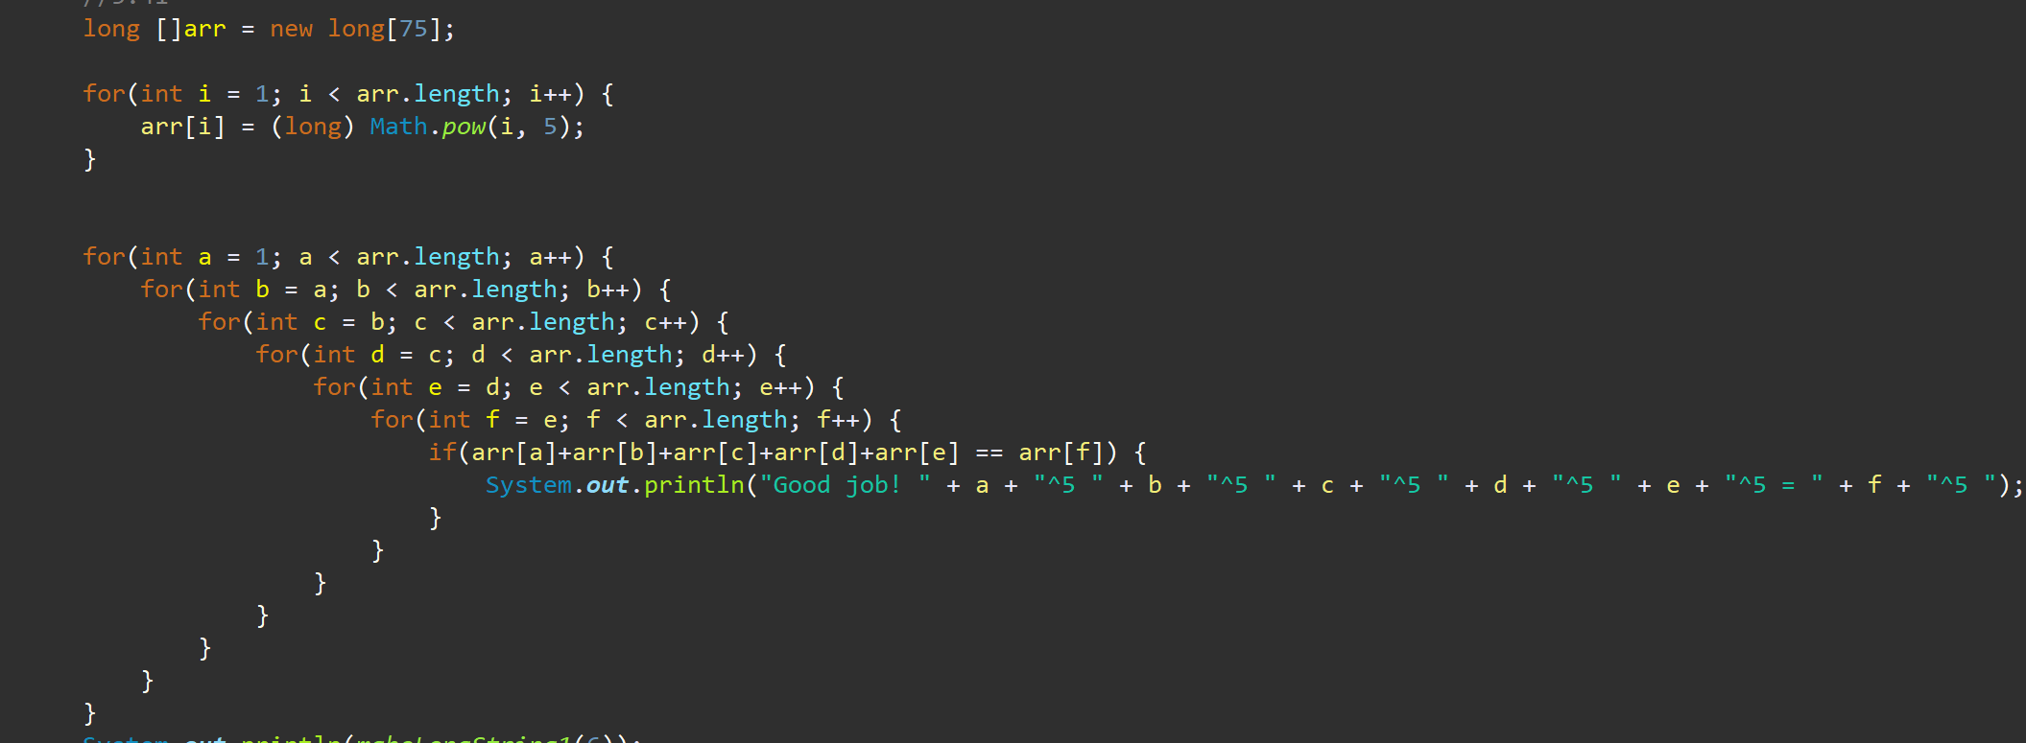

Answer



**5.44:** checked the code given to me and found out the BigOh time was N it was linear for both methods.

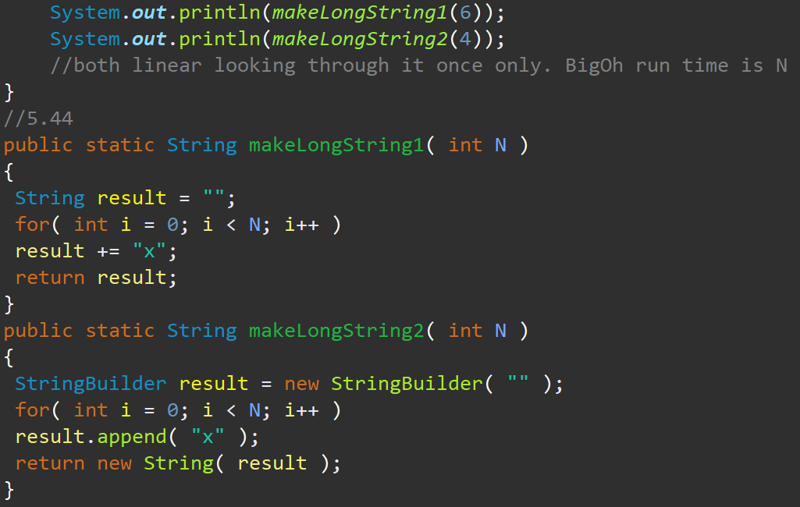

Answer

